**Neutral Networks & Deep Learning ICP 3**

**GitHub :**

[**https://github.com/YaminiSai786/CS5720-Neural-Networks-Deep-Learning---ICP**](https://github.com/YaminiSai786/CS5720-Neural-Networks-Deep-Learning---ICP)

**Video Link:**

[**https://github.com/YaminiSai786/CS5720-Neural-Networks-Deep-Learning---ICP**](https://github.com/YaminiSai786/CS5720-Neural-Networks-Deep-Learning---ICP)

**ICP 3 - Program 1**

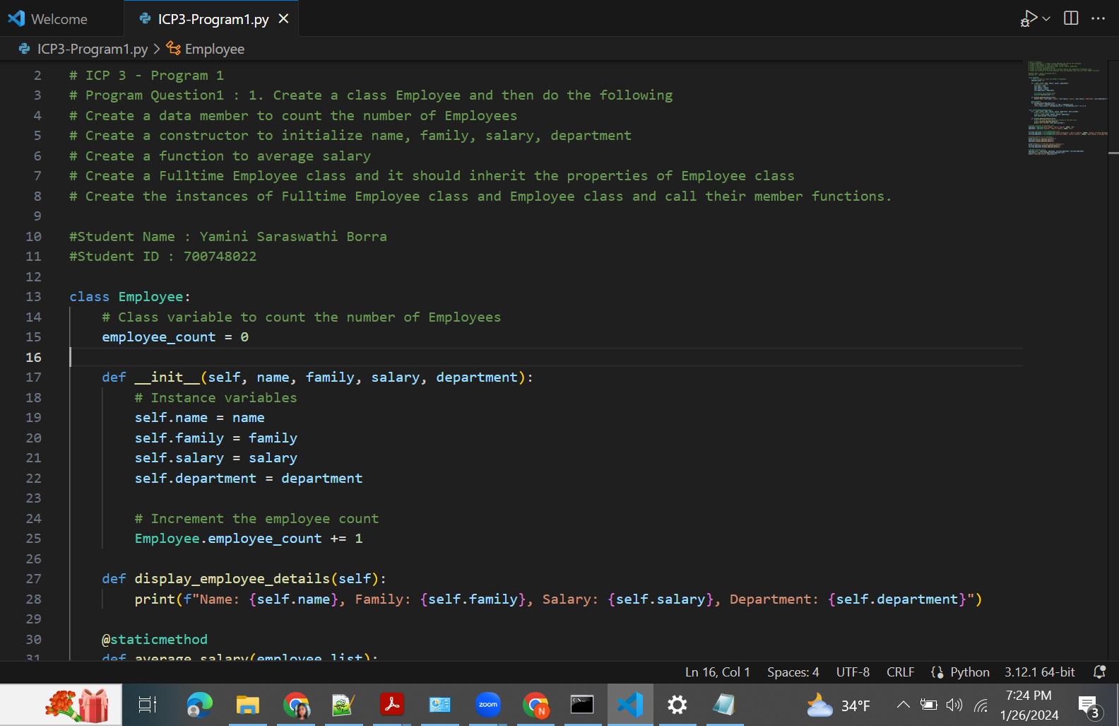

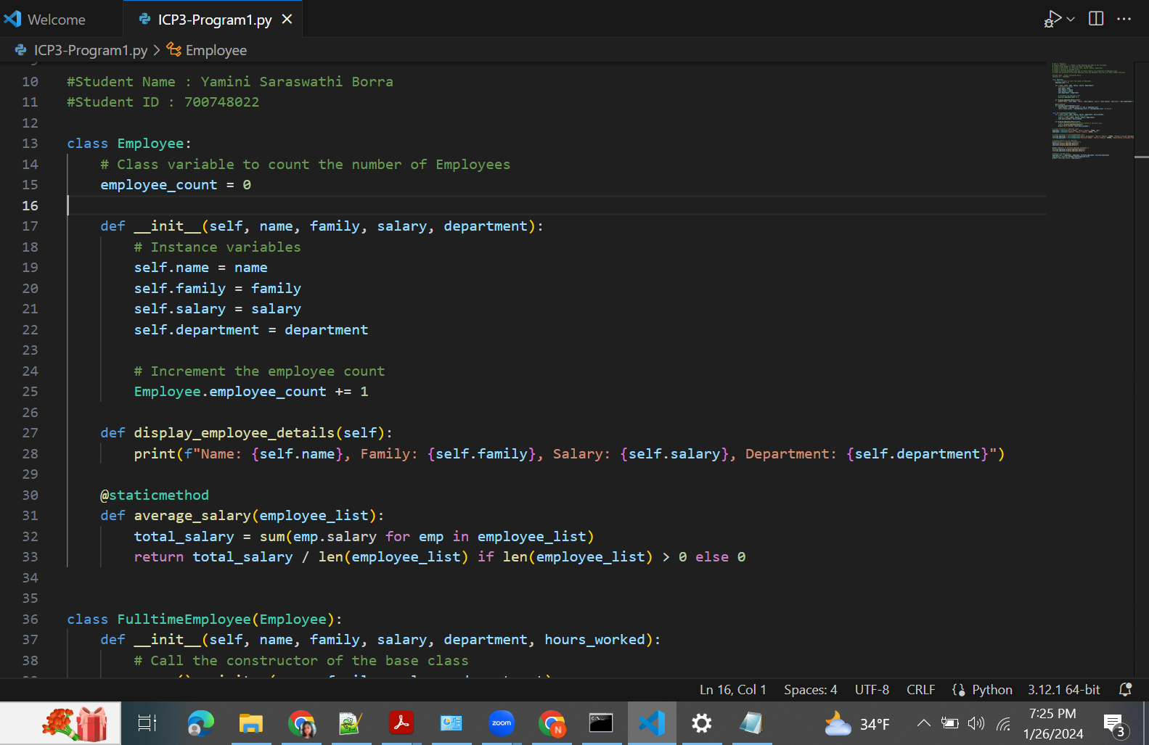

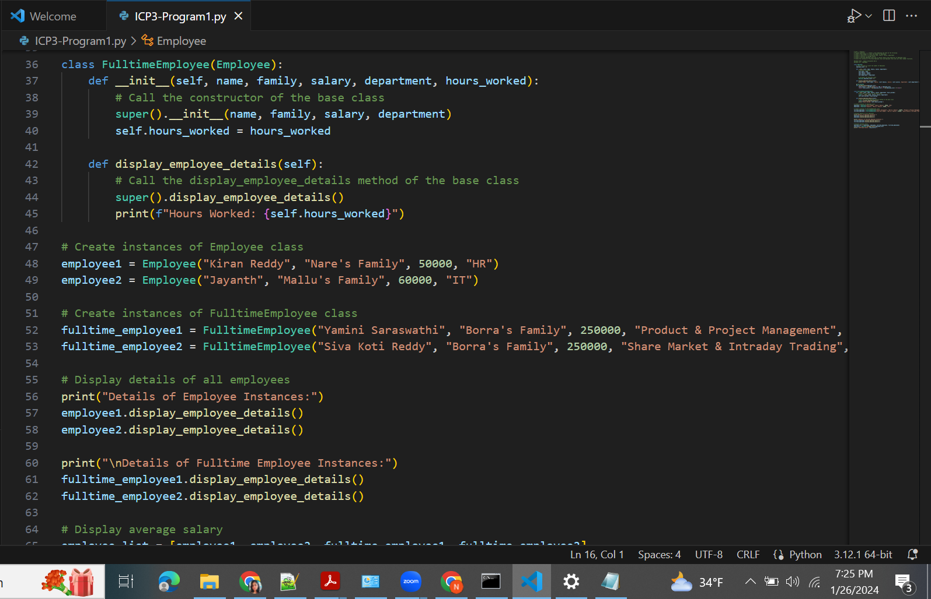

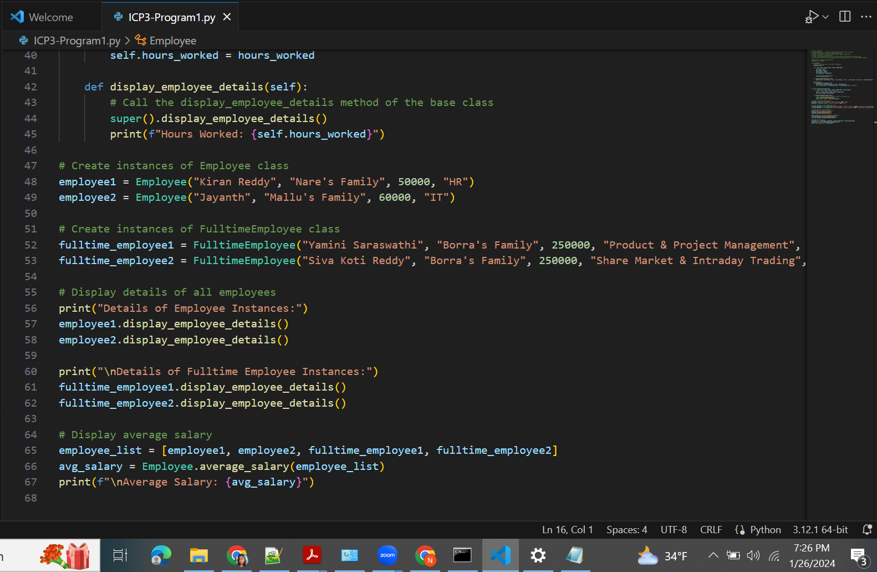

**ICP 3 - Program 1 - Result**

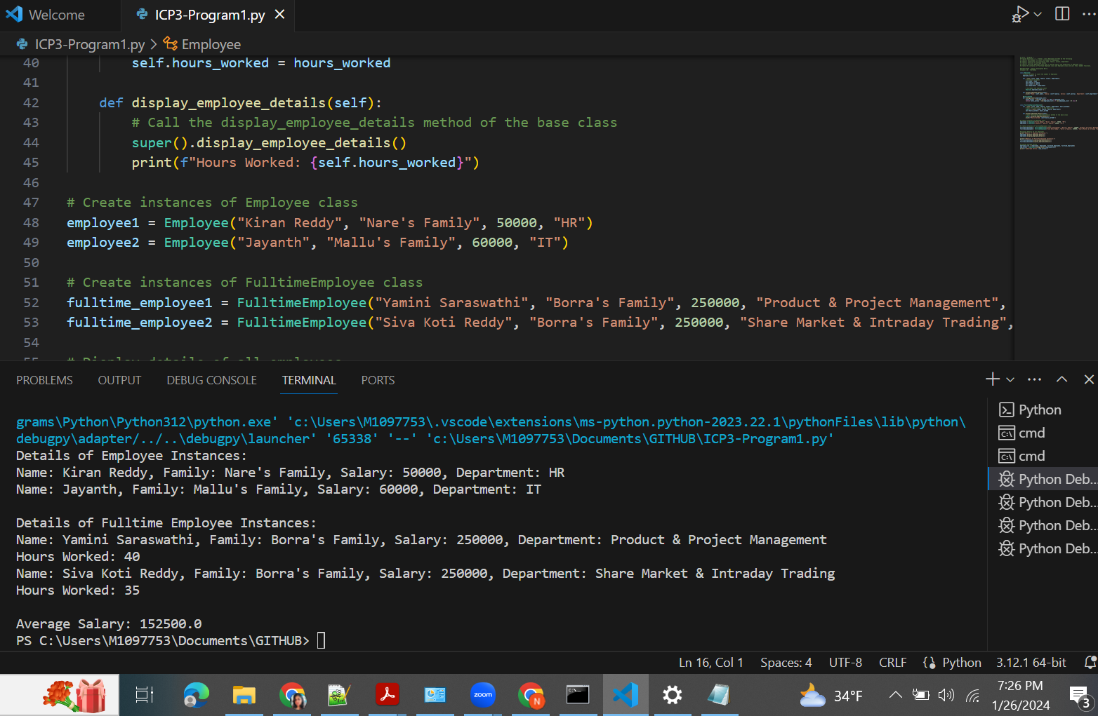

**ICP 3 - Program 2**

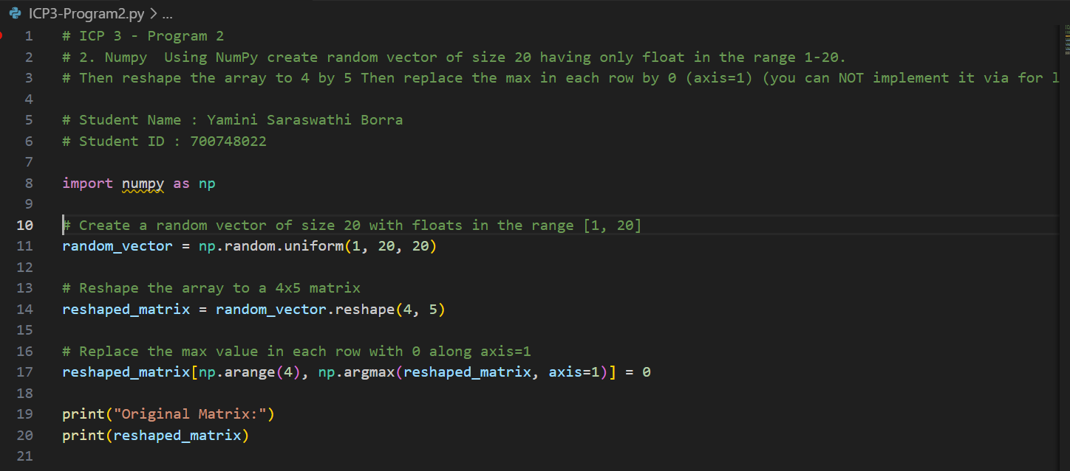

**ICP 3 - Program 2 - Result**

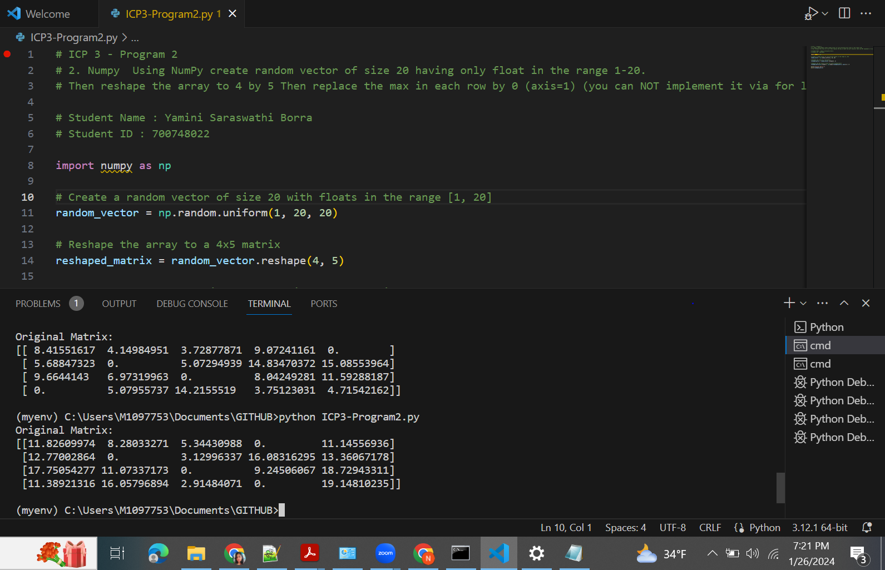

**Program 2 Result**

